Steps for ACN Lab3 Assignment

Under 4.6.5 Click on both the marked options.

First one (marked red ) is a PDF, save that to your local machine.

Once you click on the second link, you get a download like below:

Make sure you are doing this on the computer where you have Cisco packet tracer installed.

Click on open file.

You should see packet tracer application opened as below:

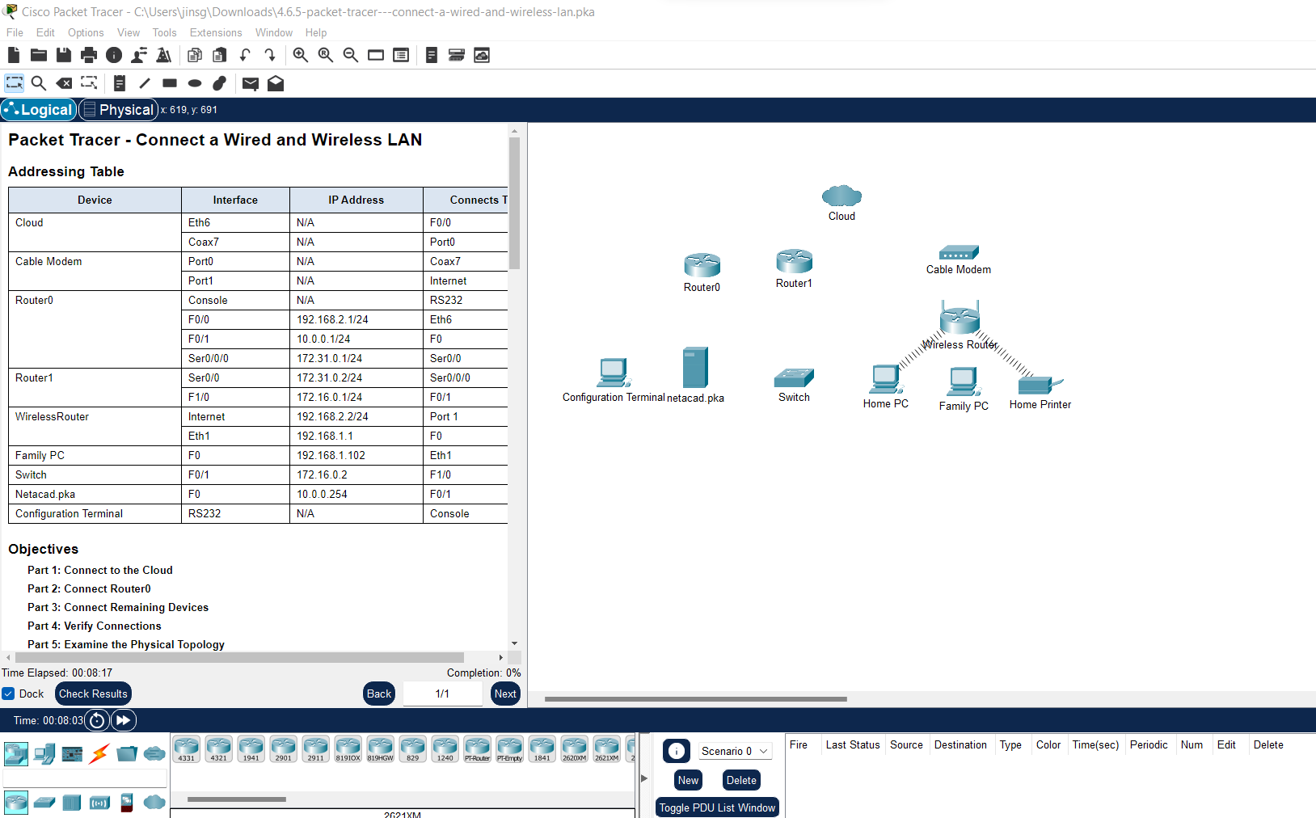

Then I remembered, we have to do this inside a folder with our roll number (nanmayulla lokame ).

And when you take screenshots for assignments, always make sure the folder path on the top is visible.

So I copy pasted the downloaded file into a new folder and double-click on it.

So far so good. The next step is to follow the instructions in the pdf that we downloaded initially.

Before you start, if you ever made a change accidentally or want to correct, you can right click and delete or go to edit menu and undo. Keep saving your work (Ctrl +S)

Instructions Part 1: Connect to the Cloud Step 1: Connect the cloud to Router0. a. At the bottom left, click the orange lightning icon to open the available Connections. b. Choose the correct cable to connect Router0 F0/0 to Cloud Eth6. Cloud is a type of switch, so use a Copper Straight-Through connection. If you attached the correct cable, the link lights on the cable turn green.

Click on the lightening and select the third wire

Drag drop as in below image. On cloud , select Ethernet 6 and on Router 0, select FastEthernet 0.

If you are lucky , you will see below (retry until you are lucky or watch a youtube tutorial)

Step 2: Connect the cloud to Cable Modem. Choose the correct cable (Coaxial, the blue one) to connect Cloud Coax7 to Modem Port0. If you attached the correct cable, the link lights on the cable turn green

Part 2: Connect Router0

Step 1: Connect Router0 to Router1. Choose the correct cable (see below image for red wire) to connect Router0 Ser0/0/0 to Router1 Ser0/0. Use one of the available Serial cables. If you attached the correct cable, the link lights on the cable turn green.

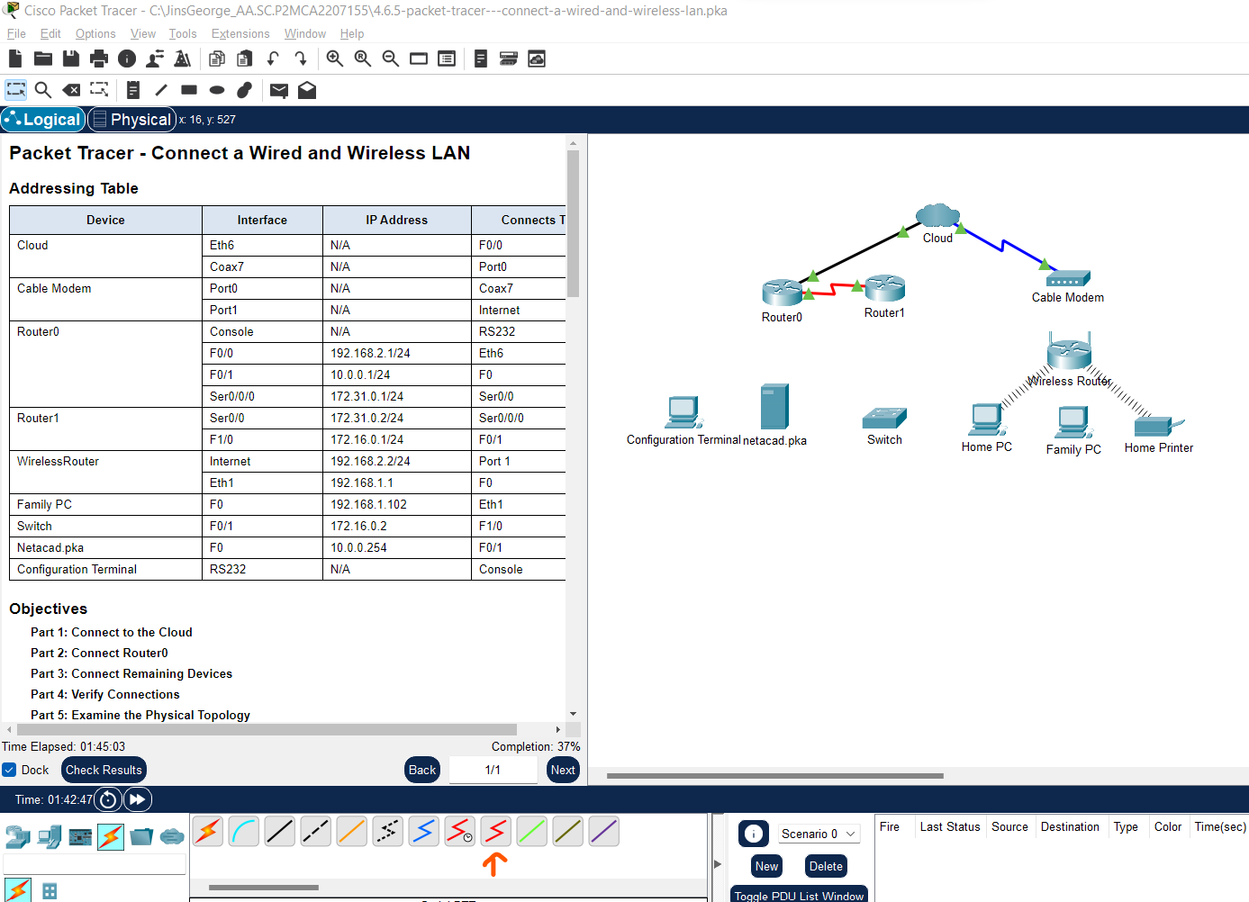

Step 2: Connect Router0 to netacad.pka.

Choose the correct cable (third one – copper crosss over) to connect Router0 F0/1 to netacad.pka F0. Routers and computers traditionally use the same wires to transmit (1 and 2) and receive (3 and 6). The correct cable to choose consists of these crossed wires. Although many NICs can now autosense which pair is used to transmit and receive, Router0 and netacad.pka do not have autosensing NICs. If you attached the correct cable, the link lights on the cable turn green.

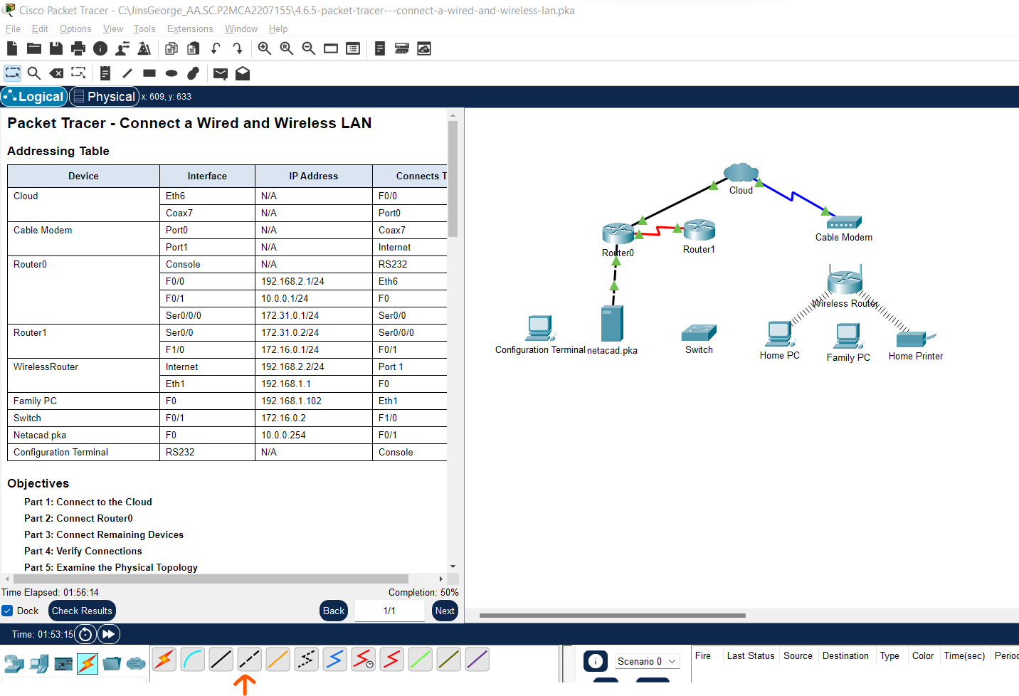

Step 3: Connect Router0 to the Configuration Terminal. Choose the correct cable(first blue wire) to connect Router0 Console to Configuration Terminal RS232. This cable does not provide network access to Configuration Terminal, but allows you to configure Router0 through its terminal. If you attached the correct cable, the link lights on the cable turn black.

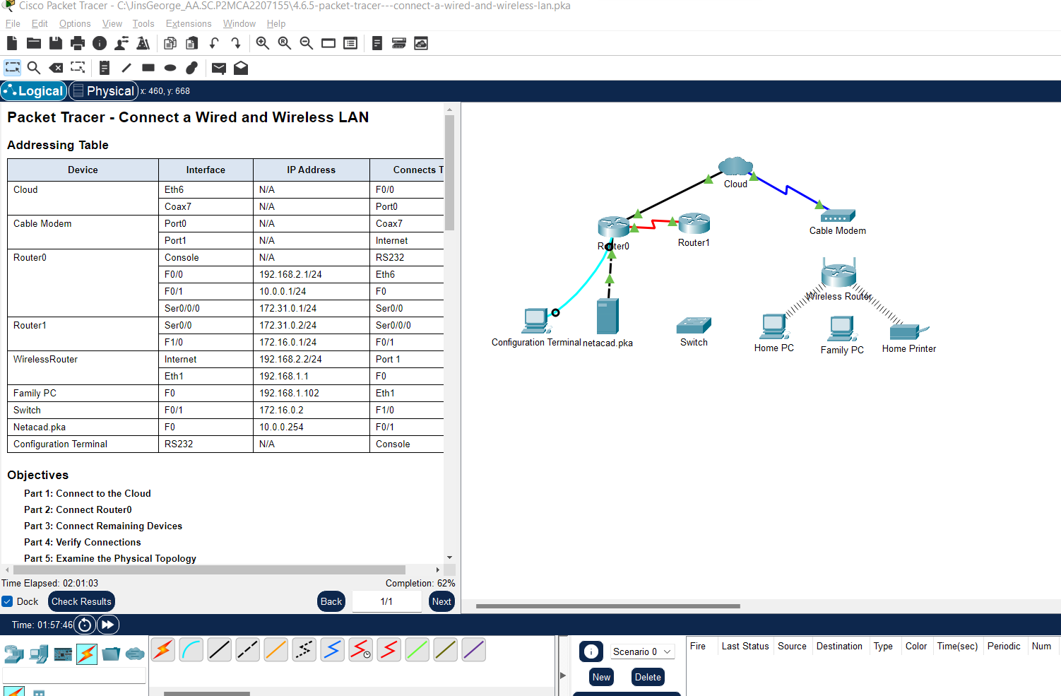

Part 3: Connect Remaining Devices

Step 1: Connect Router1 to Switch. Choose the correct cable (Fiber) to connect Router1 F1/0 (last in the list when you click on router) Switch F0/1. If you attached the correct cable, the link lights on the cable turn green. Allow a few seconds for the light to transition from amber to green.

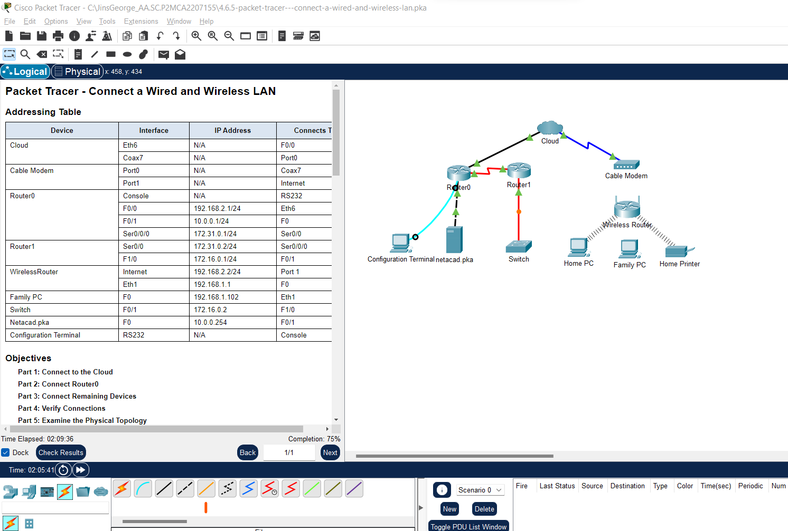

Step 2: Connect Cable Modem to Wireless Router. Choose the correct cable (Copper straight through) to connect Cable Modem Port1 to Wireless Router Internet port. If you attached the correct cable, the link lights on the cable will turn green

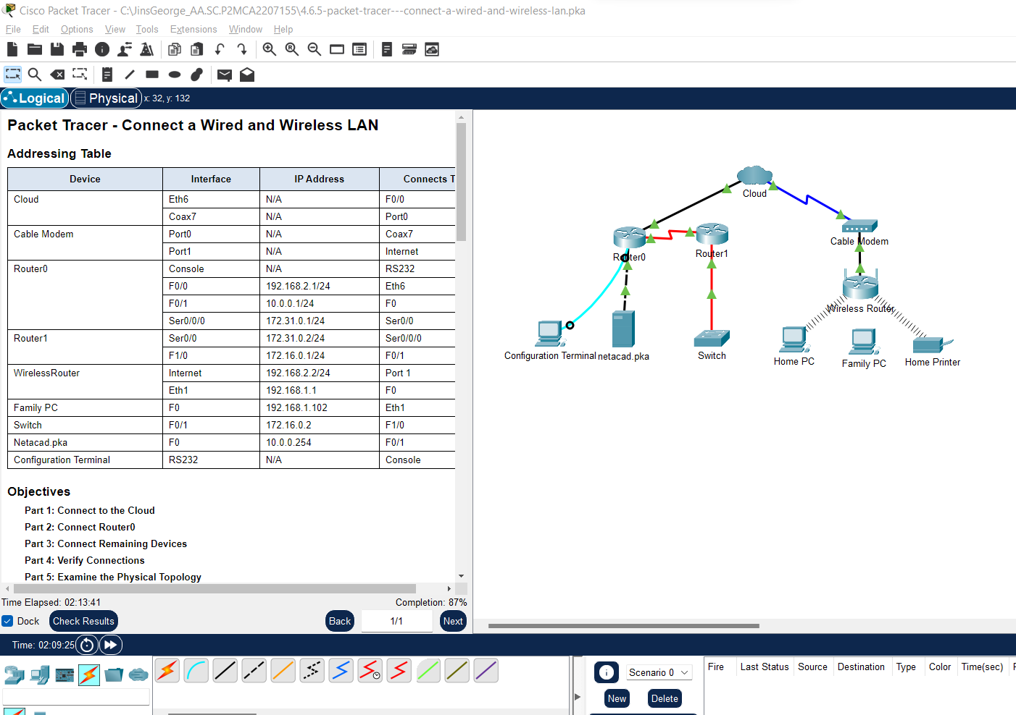

Step 3: Connect Wireless Router to Family PC. Choose the correct cable (Copper Straight through) to connect Wireless Router Ethernet 1 to Family PC (FasterEthernet). If you attached the correct cable, the link lights on the cable turn green.

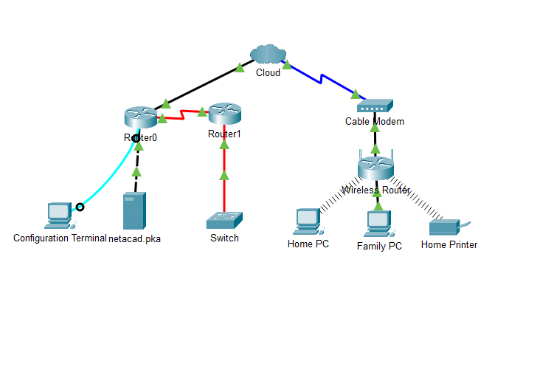

Here comes the fun part (funnier for some)

Part 4: Verify Connections

Step 1: Test the connection from Family PC to netacad.pka.

1. Open the Family PC command prompt and ping netacad.pka.

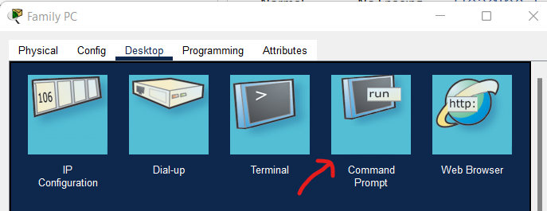

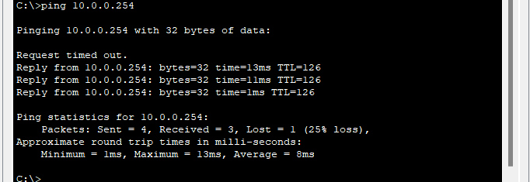

How did I get that IP address ? I clicked on netcad.pka server icon, clicked on IP Configuration and copied the IPv4 address

b. Open the Web Browser ( family PC -> Desktop-> last one on the top ;Web Browser) and the web address http://netacad.pka

Step 2: Ping the Switch from Home PC. Open the Home PC command prompt and ping the Switch IP address of to verify the connection.

To get switch ip, open switch CLI and type ‘ show ip interface’

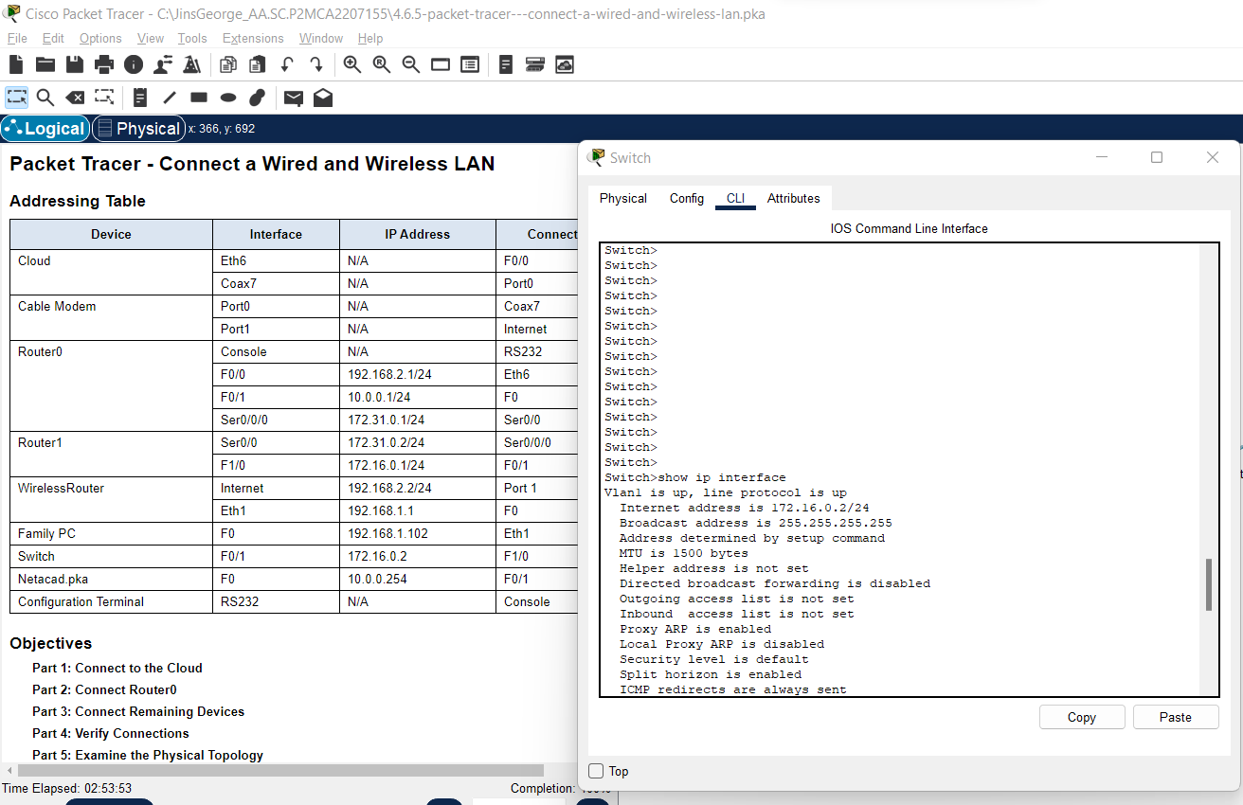

Come back to family pc command prompt and ping the copied ip

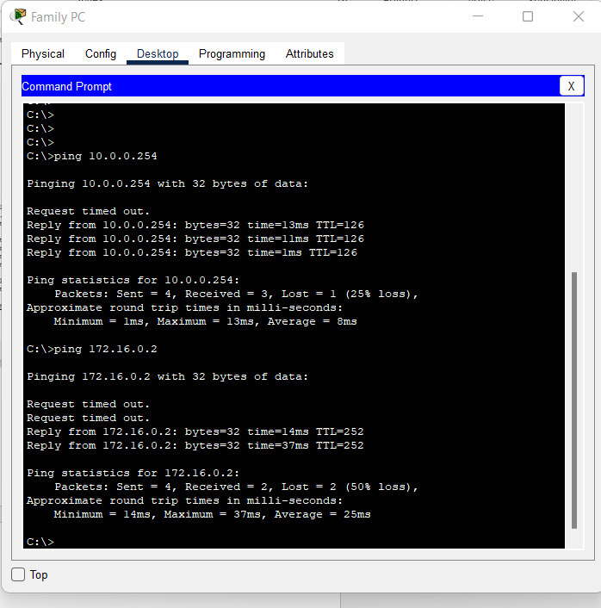

Step 3: Open Router0 from Configuration Terminal. a. Open the Terminal of Configuration Terminal and accept the default settings.

b. Press Enter to view the Router0 command prompt.

c. Type show ip interface brief to view interface statuses.

Click on Configuration Terminal-> Select Desktop-> Select terminal -> Click Ok-> press Enter

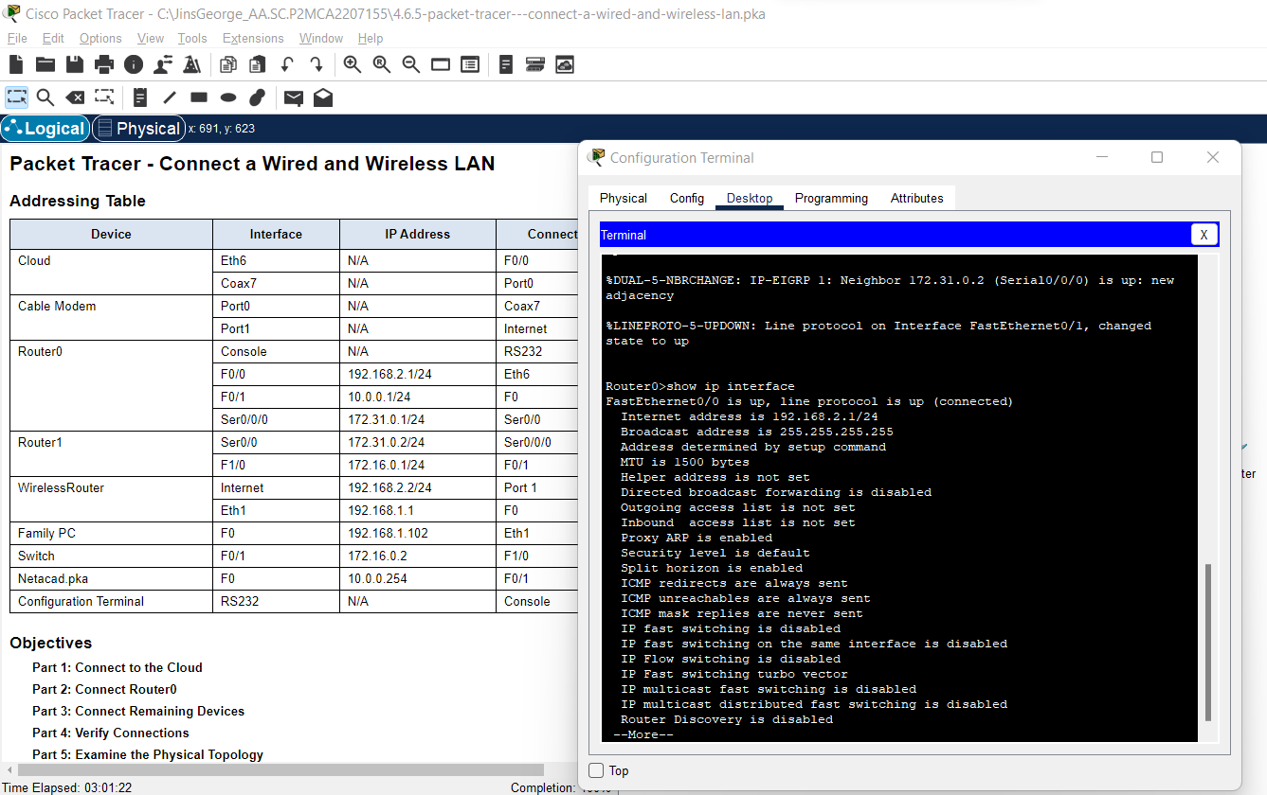

Part 5: Examine the Physical Topology

Part 5 is just examining further for learning purpose, its upto you, you can do it or skip